Write C++/Java program to draw a convex polygon and fill it with desired color using Seed  
fill algorithm. Use mouse interfacing to draw polygon.

[11-1](https://abhiyatrana.files.wordpress.com/2017/03/11-1.docx)

import java.awt.*;  
import java.awt.event.*;

public class Mouse extends Frame implements MouseMotionListener,MouseListener  
{  
int a=0,b=0;  
Robot robot;  
int x1[];  
int y1[];  
int n1=5;  
int i=-1;  
public Mouse(String str)  
{  
super(str);  
try {  
robot= new Robot();  
} catch (AWTException ex) {

}  
x1=new int[5];  
y1=new int[5];  
addMouseListener(this);  
addMouseMotionListener(this);  
}

public void mouseClicked(MouseEvent me)  
{  
if(i<3)  
{  
i++;  
x1[i]=me.getX();  
y1[i]=me.getY();  
if(i==3)  
{  
x1[4]=x1[0];  
y1[4]=y1[0];  
repaint();  
}

}  
else  
{  
//Point p1= me.getLocationOnScreen();  
a=me.getX();  
b=me.getY();  
System.out.println(a+” “+b);  
repaint();  
}  
}  
public void paint(Graphics g)  
{  
g.setColor(new Color(0,0,0));  
g.drawPolygon(x1,y1,n1);  
if(a!=0)  
poly(a,b,g);  
}  
void poly(int x, int y,Graphics g)  
{  
Color color=robot.getPixelColor(x, y);  
if(color.equals(new Color(255,255,255)))  
{  
g.drawLine(x, y, x, y);  
poly(x+1,y,g);  
poly(x-1,y,g);  
poly(x,y+1,g);  
poly(x,y-1,g);  
}  
}  
public static void main(String args[]) throws AWTException  
{  
Mouse c= new Mouse(“CGAssignmentB11”);  
c.setBounds(0, 0,400, 400);  
c.setVisible(true);  
c.addWindowListener(new WindowAdapter(){  
public void windowClosing(WindowEvent we)  
{  
System.exit(0);  
}  
});  
}  
public void mouseEntered(MouseEvent m){}  
public void mouseExited(MouseEvent m){}  
public void mousePressed(MouseEvent m){}  
public void mouseReleased(MouseEvent m){}  
public void mouseMoved(MouseEvent m){}  
public void mouseDragged(MouseEvent m){}

}

/*********Output*********

[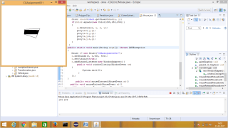](https://abhiyatrana.wordpress.com/2017/03/21/experiment-11eas/11_a/)

[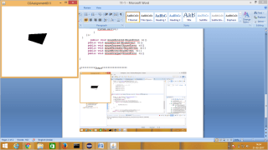](https://abhiyatrana.wordpress.com/2017/03/21/experiment-11eas/11-b/)